Jenkins task for Day-01

- Install jenkins and run jenkins on port number 8081.

First create an EC2 instance, and install jave in it
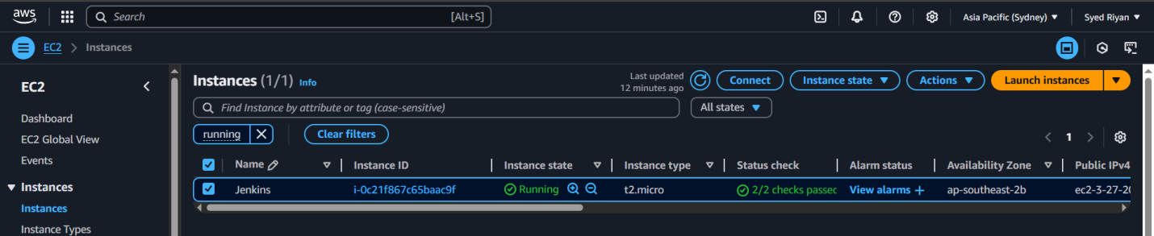
sudo yum install -y java-17-amazon-corretto
Now copy the repos using the command:
Sudo wget -O /etc/yum.repos.d/jenkins.repo \
https://pkg.jenkins.io/redhat-stable/jenkins.repo
Now import the key using the command:
sudo rpm --import https://pkg.jenkins.io/redhat-stable/jenkins.io-2023.key
Now install Jenkins: sudo yum install Jenkins
Now reload the daemon, enable, start and check status using the commands:
sudosystemctl daemon-reload
sudosystemctl enable Jenkins
sudosystemctl start Jenkins
sudosystemctl status Jenkins

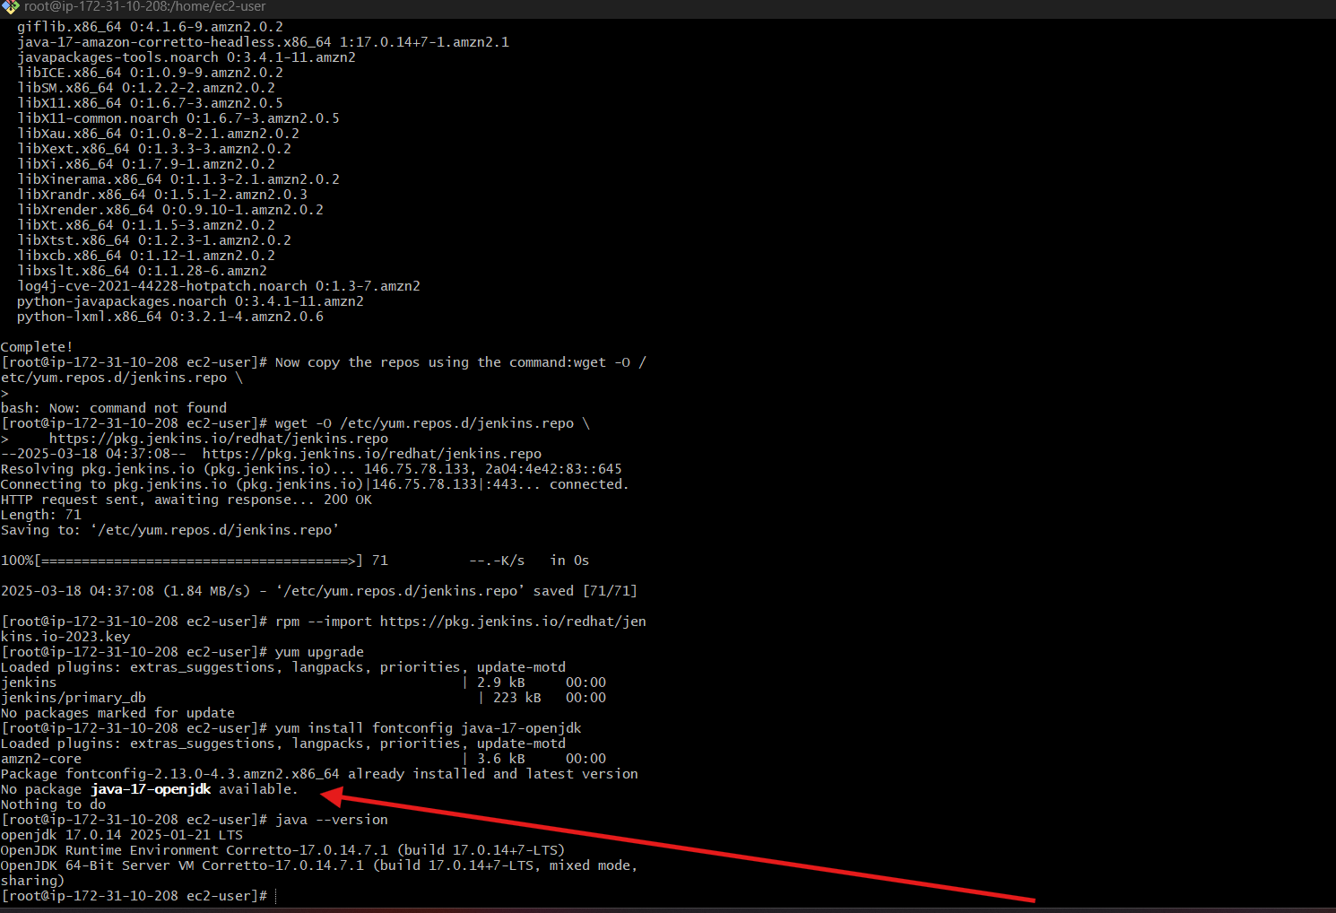
Now install Jenkins: sudo yum install Jenkins
Now reload the daemon, enable, start and check status using the commands:
sudosystemctl daemon-reload
sudosystemctl enable Jenkins
sudosystemctl start Jenkins
sudosystemctl status Jenkins
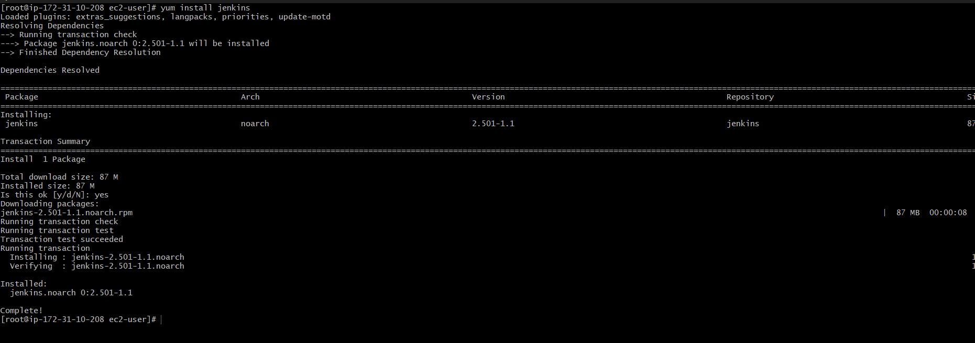
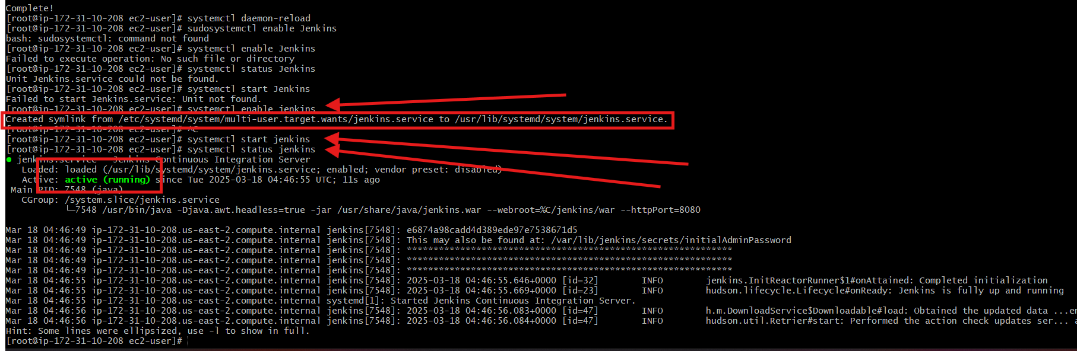
Now open the jenskins.service file
sudo vi /lib/systemd/system/jenkins.service
Add a line –httpport=8081

Also change in the Environmental line
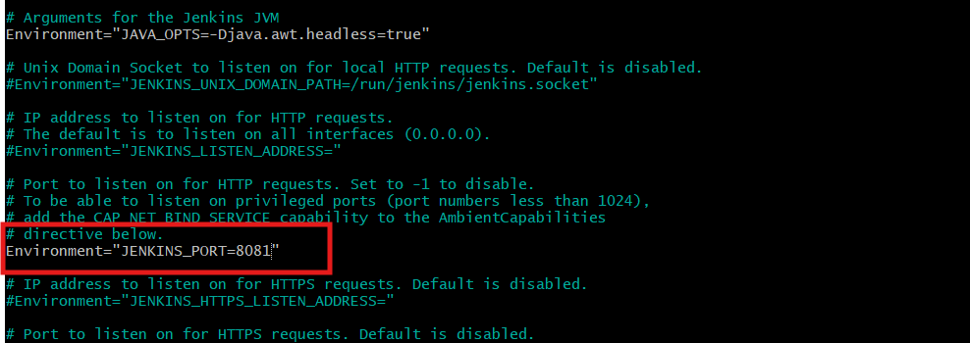

Now reload the daemon, restart Jenkins
Go to browser and copy paste the public ip of ec2 and portno 8081 : hit enter
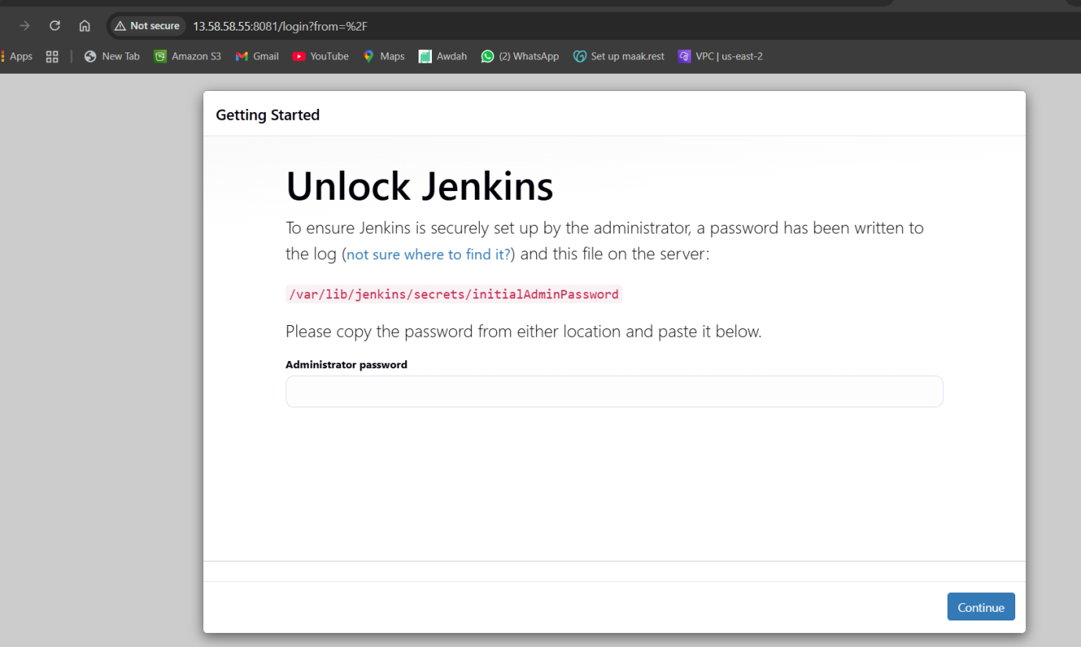
Go to loction below location to change the password , copy and paste in browser

Cat /var/lib/jenkins/secrets/initialAdminPassword

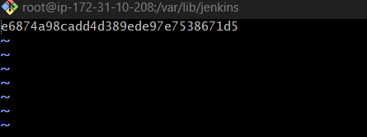
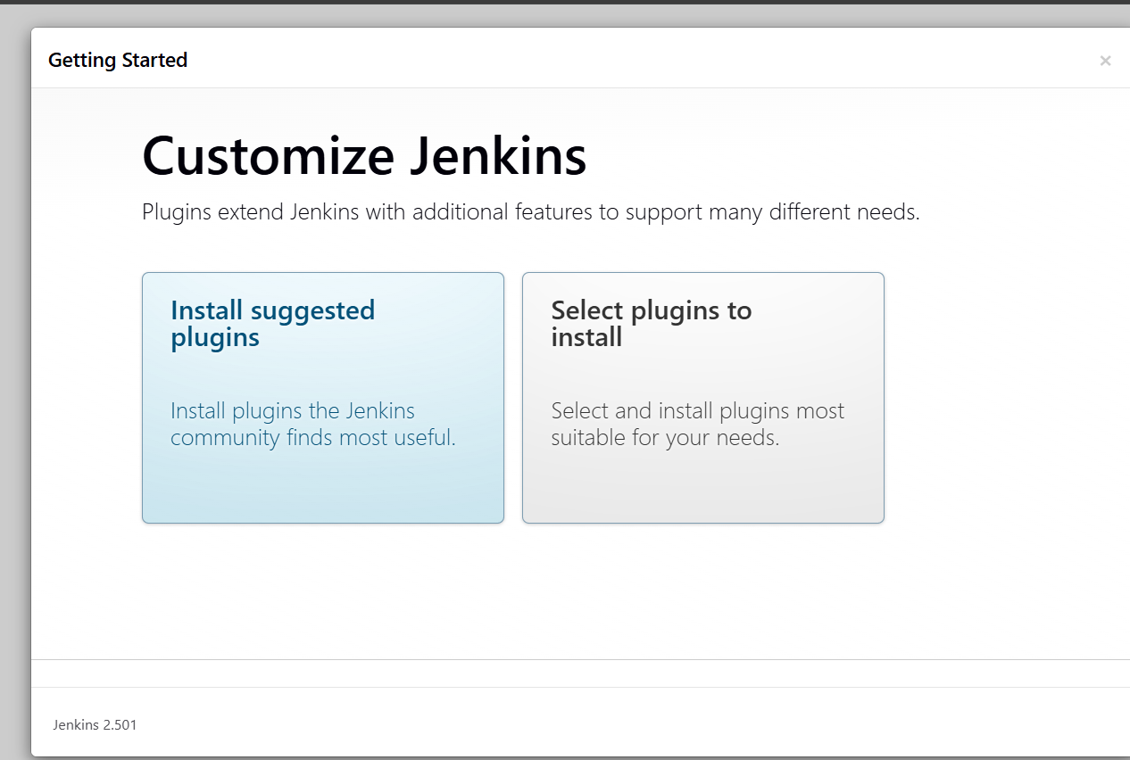
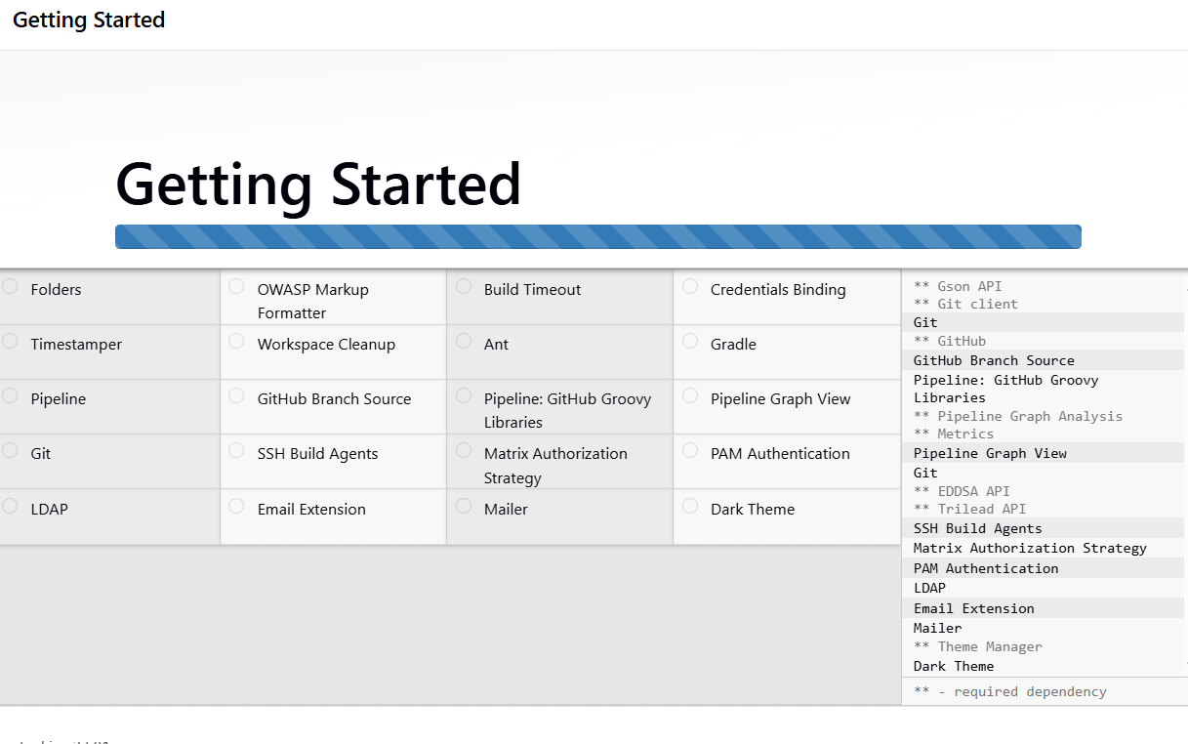
- Secure Jenkins server

To secure first we need to copy the InitialAdminPassword
Cat /var/lib/jenkins/secrets/initialAdminPassword
cbf5b87543a64d4d9e28a62ec5a26957
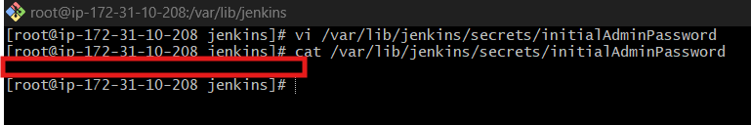
Now password has been deleted to make it seceure
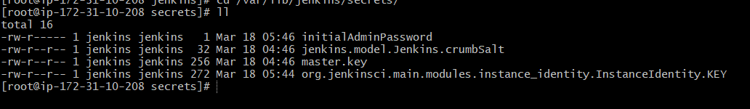
- Create users called Devops, Testing in Jenkins with Limited access.
First we are creating 2 users called Devips and Testing
Go to Manage Jenkinsuserscreate user
Provide the details
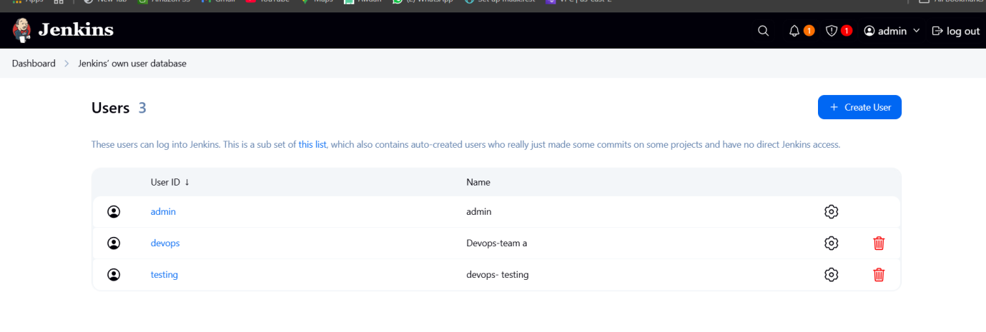
Login as admin user and password
To give limited access to the users
Go to Manage JenkinsSecurityunder Authorization
Select Project-based matrix authorization strategy
Add user id name for both to add in means ,name of the user
Add the users Devops and Testing and mark the boxes with limited access and click on save

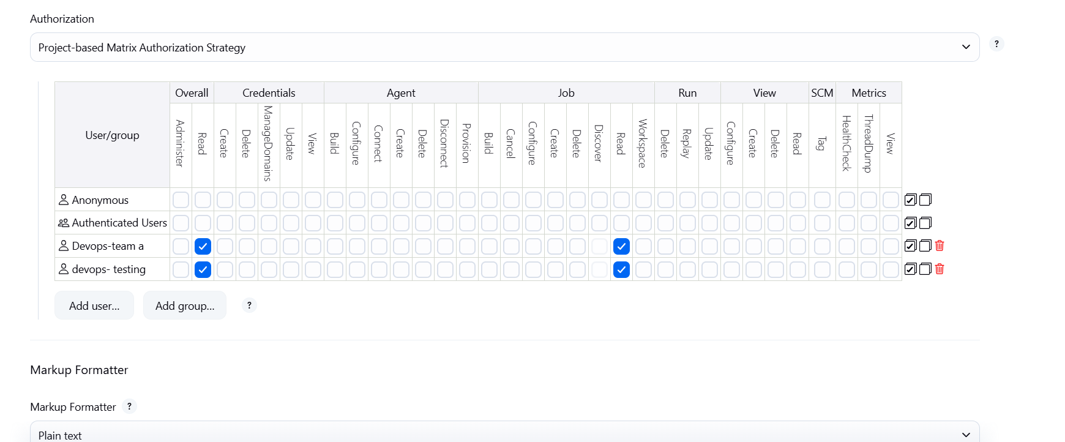

Login from 1st user devops
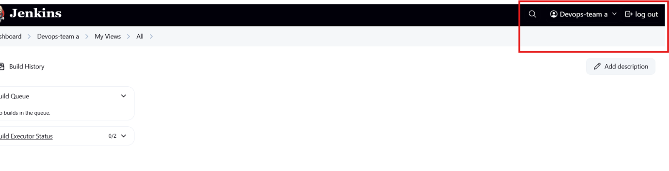login from 2nd user testing
` 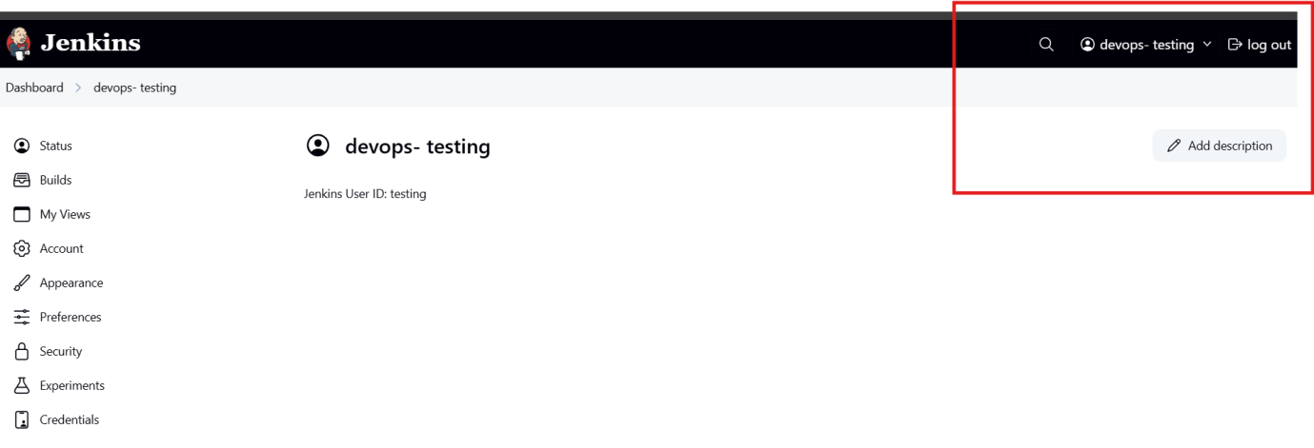

- Configure labels and restrict the jobs to execute based on label only.

To create label
First install plugins, to install plugin go to Manage Jenkinsplugins
Search for Node and Label parameter, install the plugin role –based authorization strategy
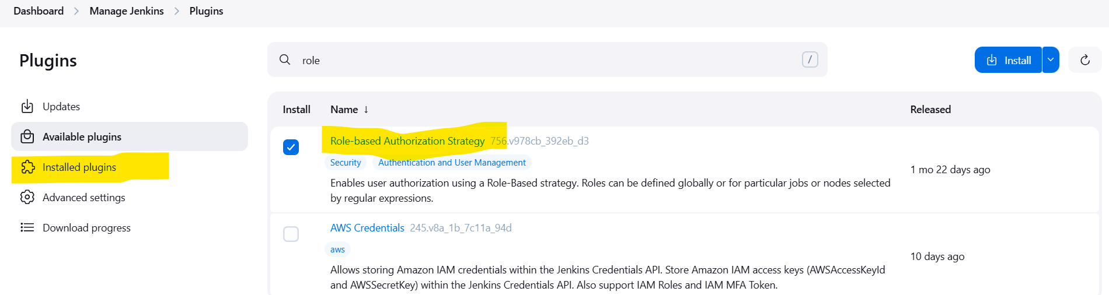
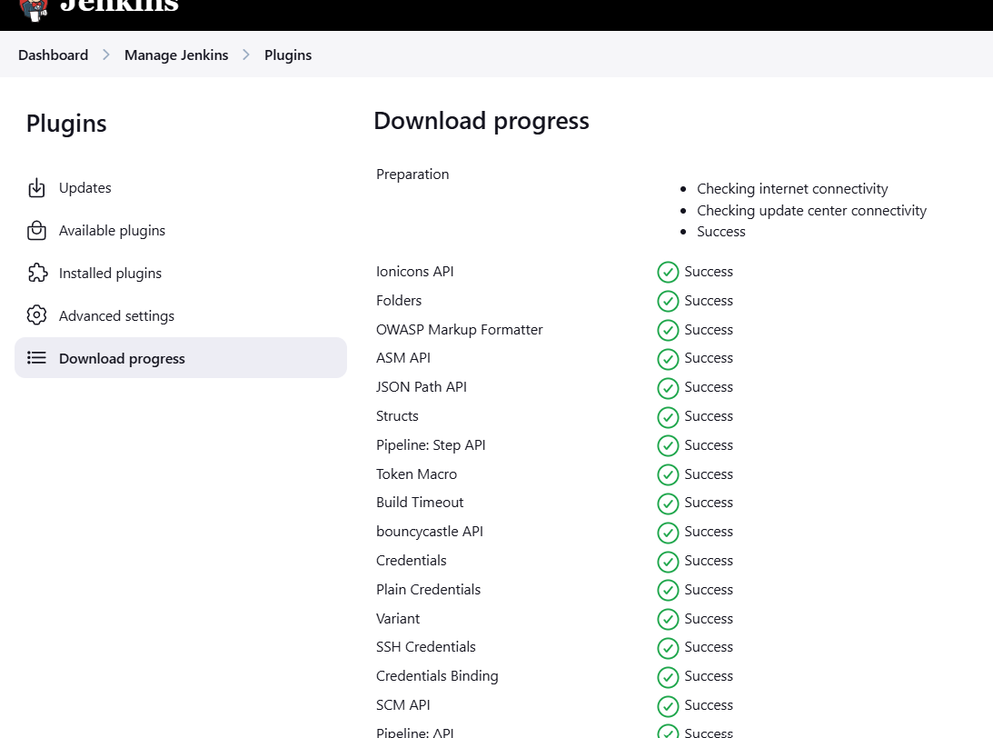

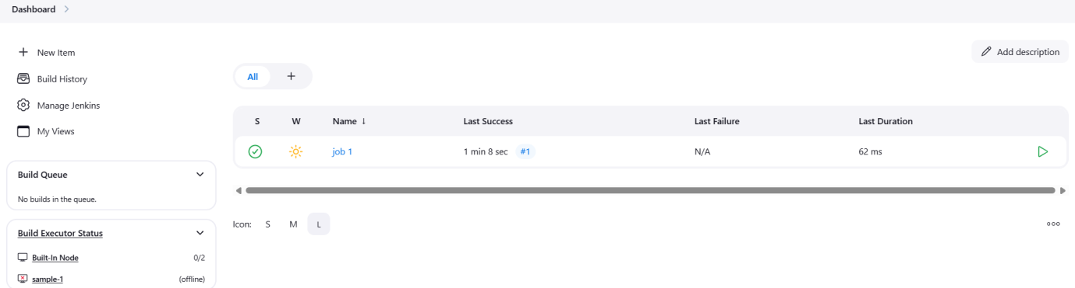
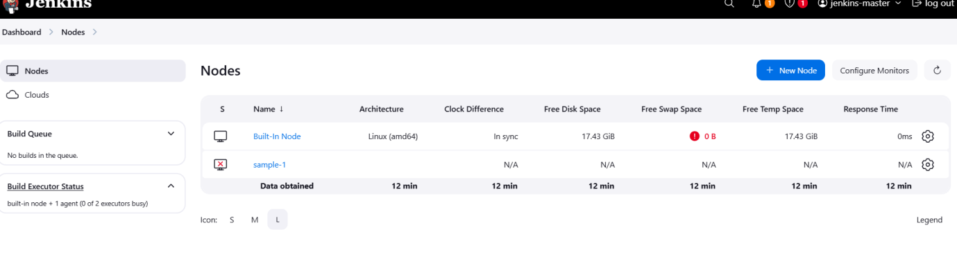
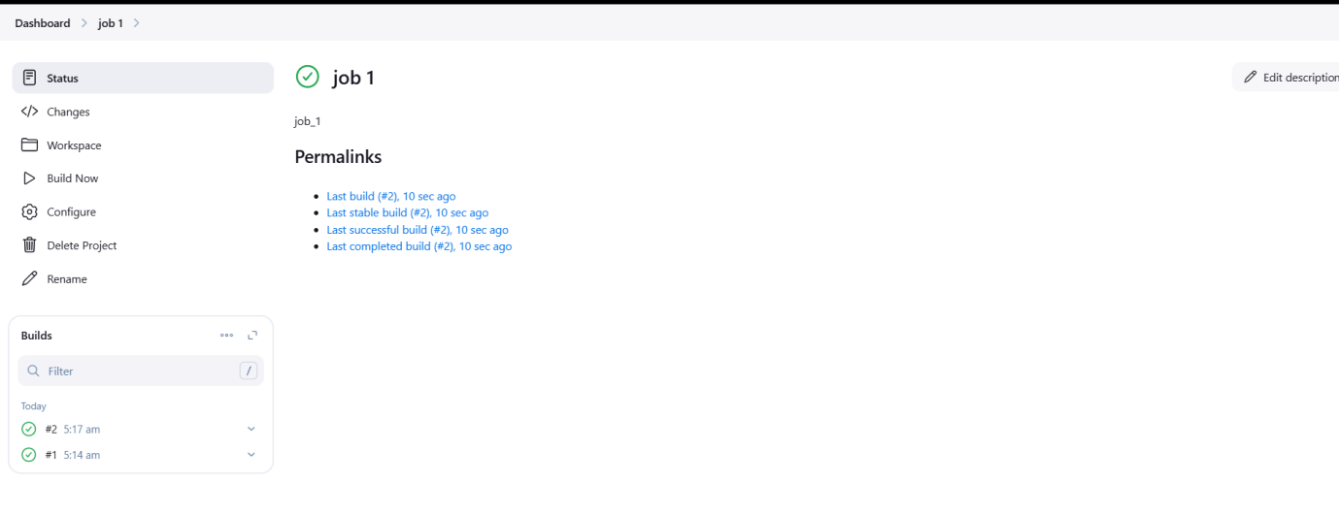
5) Create Three sample jobs using the below URL.
https://github.com/betawins/Techie_horizon_Login_app.git

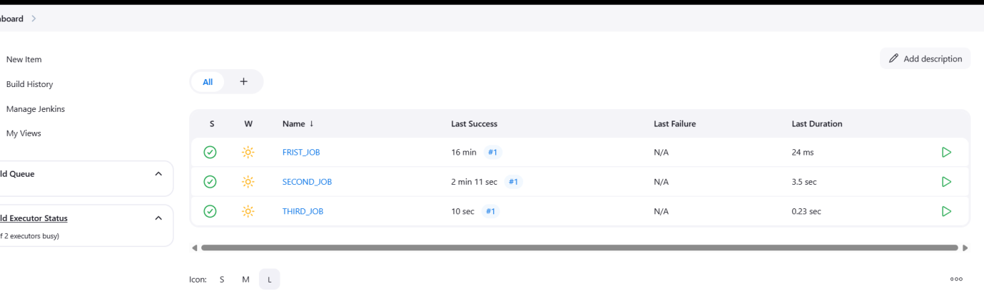
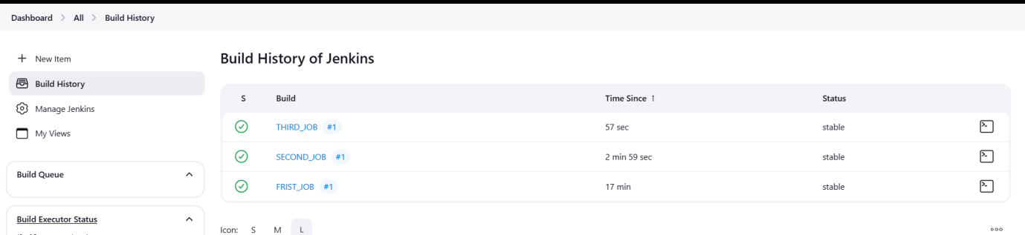
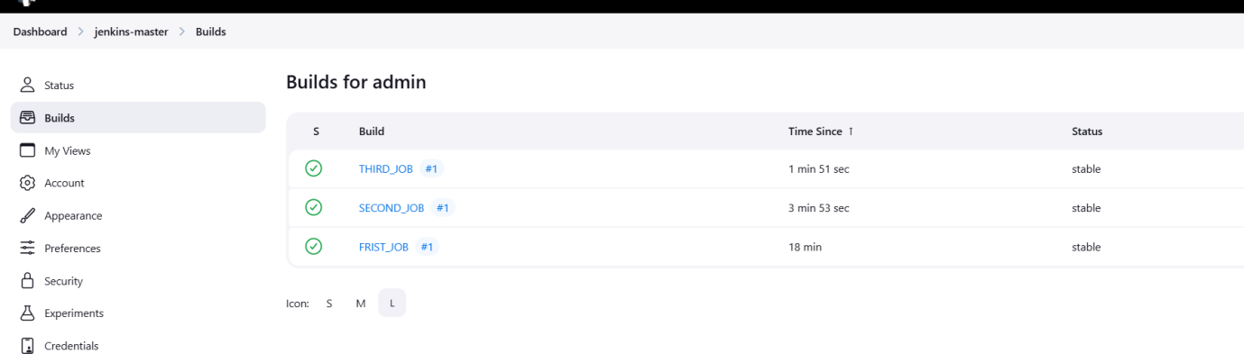
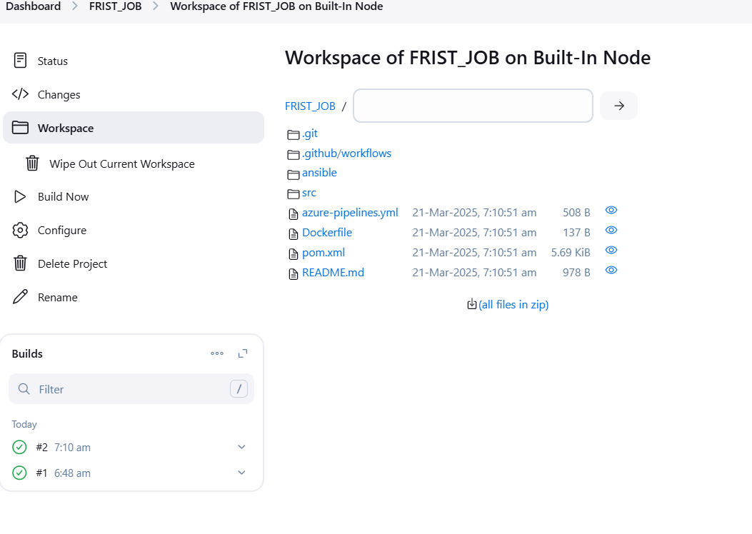

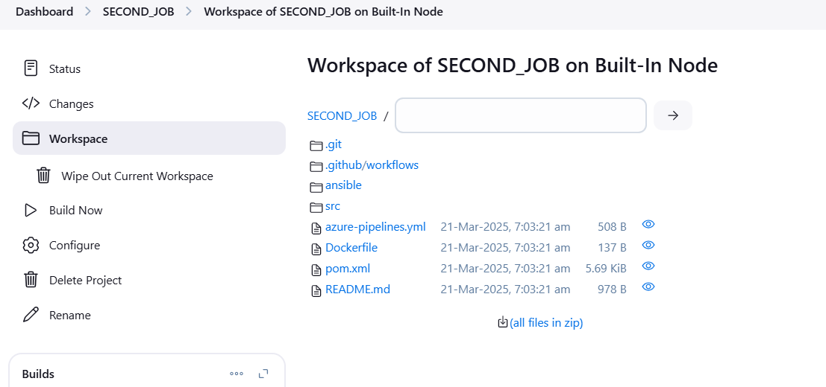
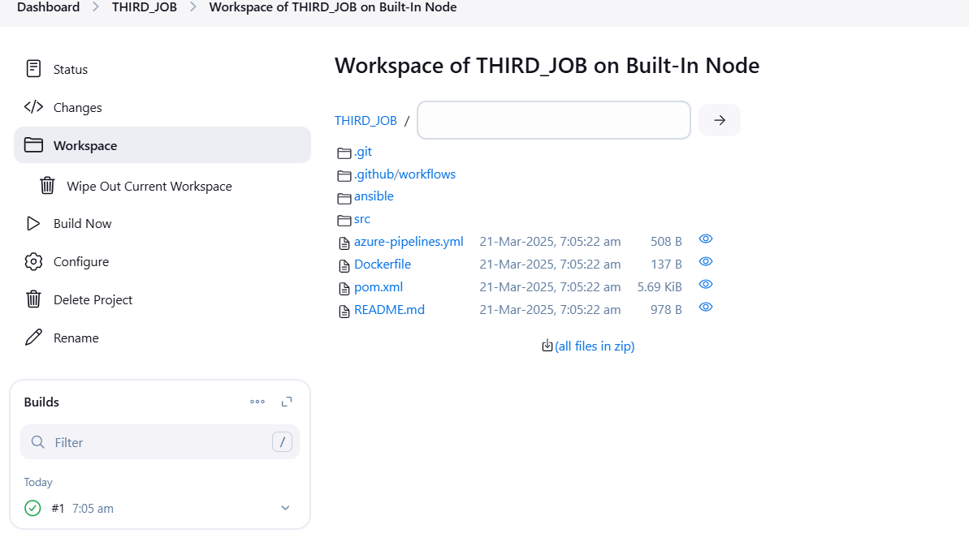

CHECK FROM JENKINS GUI SERVERS
List from first _ job . clone all the list of directories from git
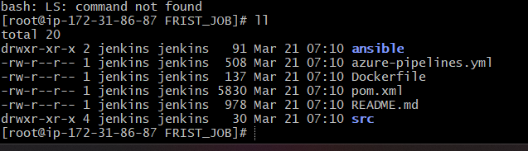
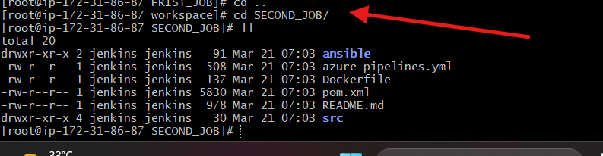
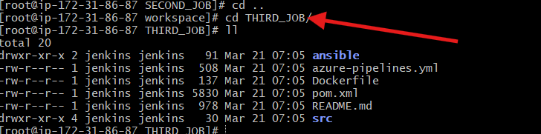
- Create one jenkins job using git hub Private repository.

Need to create a private repo in github and generate a token in github
Githubsettingdeveloper settinggenerate token
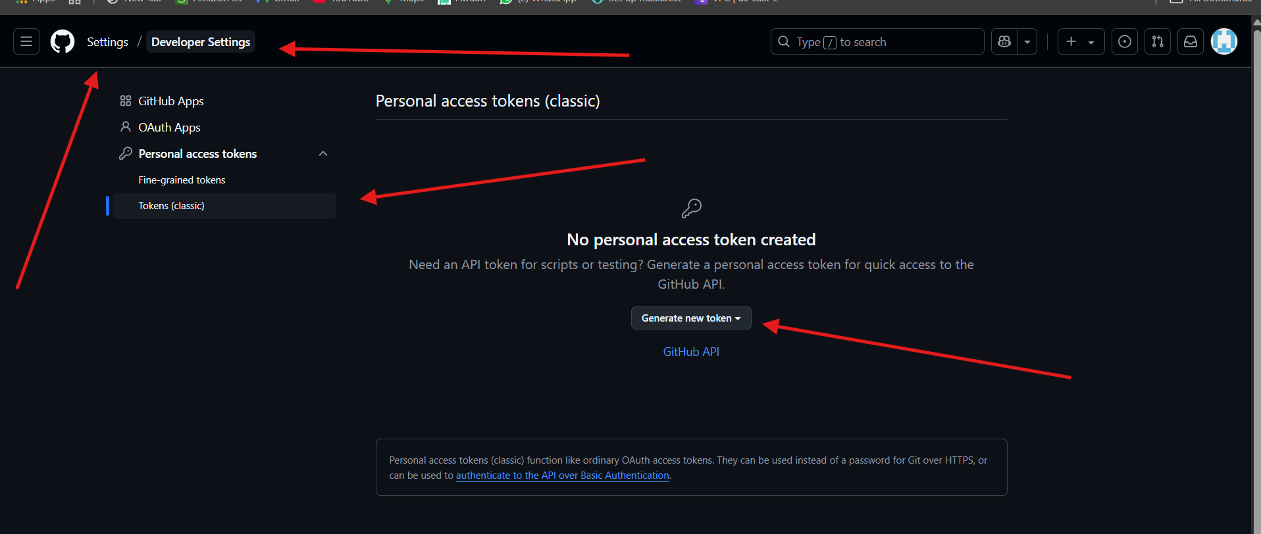

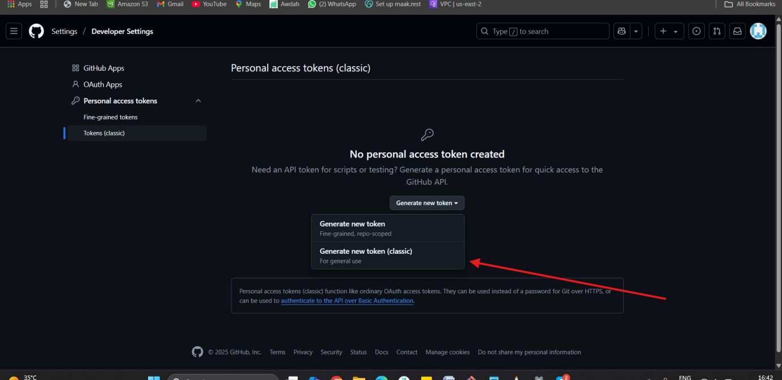

First create Personal Access Token
Go to github settings Developer settings Token (classic) Generate new token Generate new token (classic)
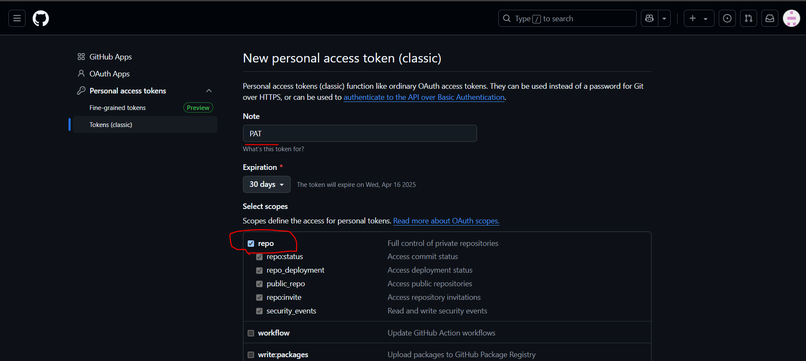
Scroll below and click on Generate Token
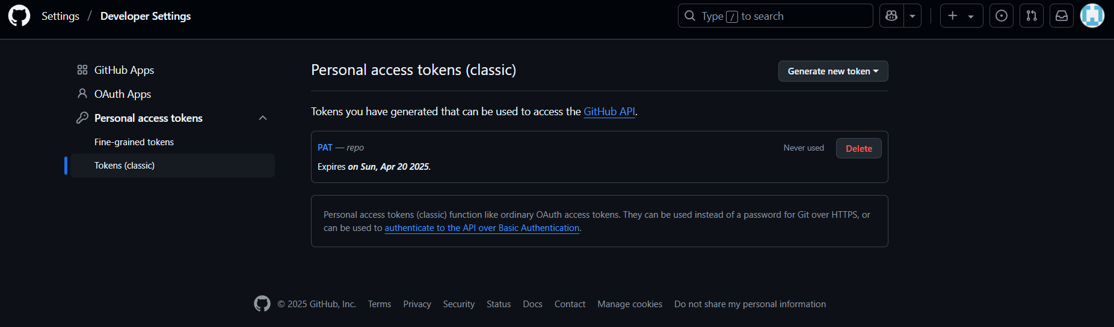
Now go to Jenkins server
Click on Dashboard → Click Manage Jenkins.
Click Manage Credentials → Select (global).
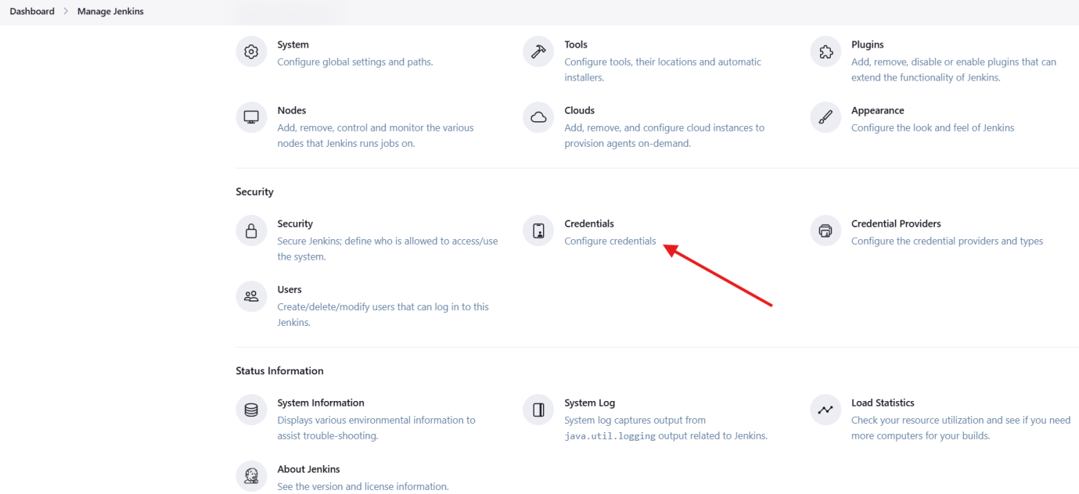
Click Add Credentials → Choose Username and Password.

Enter:
Username: MAAK21
Password: 08Q81A0521
Click on save.
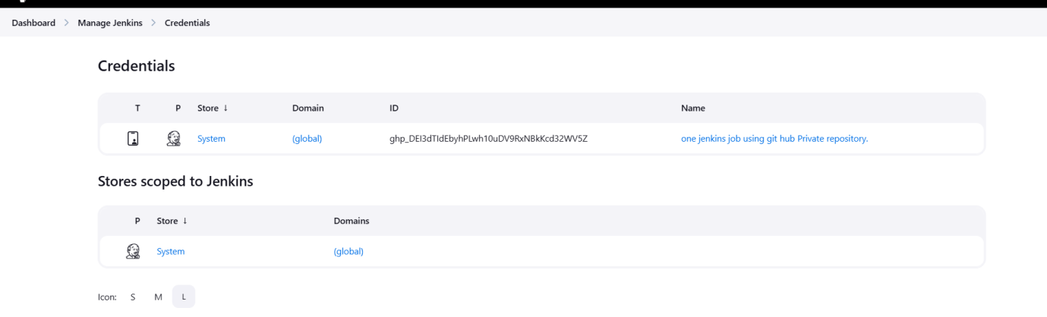

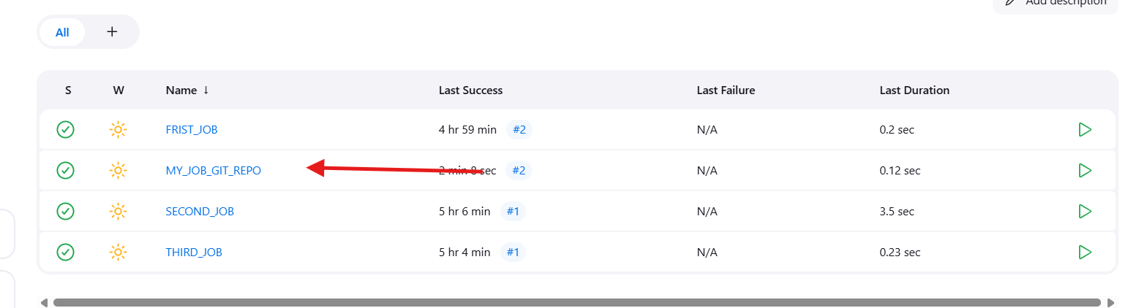
Now click on Build Now
Now check in Github and in Jenkins EC2 server the files of Github would have been downloaded
